Question 01: Show that the Post Correspondence Problem (PCP) is decidable over unary alphabet.

Answer:
The Post Correspondence Problem (PCP) is decidable over unary alphabet. We can describe a Turning Machine M that decides unary PCP.
Given unary PCP instance
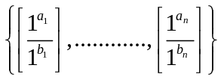
Let us design a TM M as given below:
M = “On Input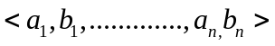”
- Check if 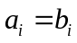 for some i. if so, accept.
- Check if there exist 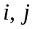 such that 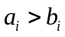 and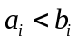. If so, accept otherwise reject.

Question 02: Prove that every t(n)-time k-tape TM has on equivalent 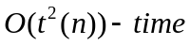 single tape TM.

Answer:
Given a k-tape TM M, we can make 1-tape TM N. N works as follows:
- On input x, convert input x to #q0#x#, …. #(the start configuration of M). This configuration says that x is on the first tape. The rest of the tape is empty and the machine is in q0.
- In each pass over the tape, change the current configuration to the next one.
- If an accepting configuration is reached, accept.
- If a rejecting configuration is reached, Reject.

Now we have to estimate, how much time does N require?
On any input x of length n, we make the following claims:
- M uses at most t(n) cells of its k-tape.
- Each configuration has length at most k t(n) = O(t(n)).
- Each pass of N requires at most O(t(n)) steps.
- N makes at most t(n) passes on its tape.

This shows that N run in time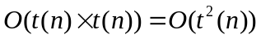. Here, we use the fact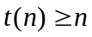.
Thus, the machine convert x to the initial configuration. This takes time O(n). So total time is given below:
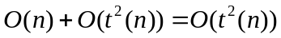

Question 03: Show that A_{TM} is not mapping reducible to E_{TM.}

Answer:
Recall that A_{TM} is undecidable, but it is recognizable so its complement 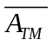is not recognizable. Note that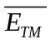, the complement of 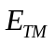is recognizable, and so since we know is undecidable, It is also not recognizable.

Proof: We give a proof by contradiction.
Assume, it is false that A_{TM} is not mapping reducible to, so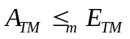.
Consider since A_{TM} is mapping reducible to, we immediately get is mapping reducible to.
Since, is recognizable, is also recognizable, but this is false, Hence a contradiction.

Question 04: Which of the following pair of numbers are relatively prime? Show the calculations that lead to your conclusions. A) 1274 & 10505 B) 7289 & 8029
Answer:
- For checking the given number 1274 & 10505 that they are relatively prime or not we use Euclidean algorithm to find Greatest Common Divisor (GCD).
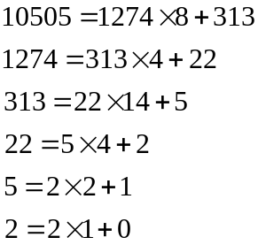
The greatest common divisor of 105050 and 1274 is 1. There for they are relatively prime.
- For checking the given number 7289 & 8029 that they are relatively prime or not we use Euclidean algorithm to find Greatest Common Divisor (GCD).
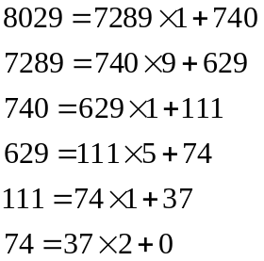
The greatest common divisor of 7289 & 8029 is 37. There for they are not relatively prime.

Question 05: G is a digraph and show that PATH is in Class P. OR Design a polynomial time algorithm that takes as input a graph G and two vertices s and t and decides if there is a path from s to t.
Answer:
We have to give a polynomial time algorithm for this problem. That is “Start BFS or DFS from s and if t appears then there is a path from s to t”.
Algorithm:
- On input <G,s,t> where G is a digraph,
- Mark s.
- Repeat till no additional nodes are marked:
- Scan the edges of G, if an edge (a,b) is found going from a, marked node a to an unmarked node b, mark b.
- If t is marked, accept, otherwise reject.

Now we have to compute the size of input. We know that input size is at least m, where m is the number of nodes in G. Thus we have to show that algorithm runs in the time polynomial in m.

The repeat loop can at most run for m time. Each time all the edges are scanned. Since the number of edges is al most m², thus step 2 takes at most m² time. So the total time is at most m³. Hence, we have shown that PATH is in p.

Question 06: A Turning Machine with stay put instead of left is similar to an ordinary turning machine, but the transition function has the form: 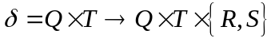. At each point the machine can move its head right or left it stay in the same position.

Show that this turning machine variant in not equivalent to the usual version. What class of language does this machine recognize?

Answer:

Remembering what it has written on the tap cells to the left of the current head position is unnecessary, because the TM is unable to return to these cells and read them.

Using NFA in the actual construction is convenient because it allows E moves which are useful for simulating the “Stay Put” TM Transition.

The transition function 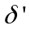 for the NFA is constructed according.
- First, we set 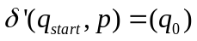 , where q₀ is the start state of the TM variant.
- Next, we set 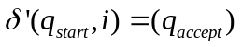for any i.
- If 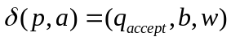 where w=R or S, we set 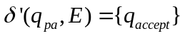.
- If 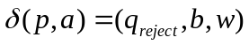 where w=R or S, we set 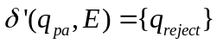.

Question 07: show that the collection of Turning-recognizable language is closed under operation of (i) Union (ii) Concatenation.

Answer:

- For any two turning recognizable languages L1 and L2, let M1 and M2 be the TMs that recognizes the union of L1 and L2:

“On input w
Rum M1 and M2 alternatively on w step by step. If either accept, accept. If both halt and reject, then reject”

If any of M1 and M2 accepts w, M1 will accepts w since the accepting TM will come to its accepting state after a finite number of steps. Note that if both M1 and M2 reject and either of them does so by looping, then TM will loop.

- Form any two Turning-recognizable languages L1 and L2, let M1 and M2 are the TMs that recognize them. We construct a NTM M’ that recognizes the concatenation of L1 and L2;
“On Input w;
  - None deterministically cut w into two parts w = w1w2.
  - Run M1 on w1. If it halts and reject, reject. If it accepts, go to stage 3.
  - Run M2 on w2. If it accepts, accept. If it halts and reject, reject.”

If there is a way to cut w into two substrings such that M1 accepts the first part and M2 accepts the second part, w belongs to the concatenation of L1 and L2 and M1 will accept w after a finite number of steps.

Question 08: Let X be the set {1, 2, 3, 4, 5} and Y be the set {6, 7, 8, 9, 10}. We describe the functions f: X - Y and g: X Y in the following tables.

N | F(n)
1 | 6
2 | 7
3 | 6
4 | 7
5 | 6
N | G(n)
1 | 10
2 | 9
3 | 8
4 | 7
5 | 6
a. Is f one-to-one? b. Is f onto? c. Is f a correspondence?
d. Is g one-to-one? e. Is g onto? f. Is g a correspondence?

- f is not one-to-one because f(1)=f(3) on the other hand g is one-to-one.
- f is not onto because there does not exist x belongs to X such that f(x)=10. But g is onto.
- g is a correspondence because g is one-to-one and onto. f is not correspondence because f is not one-to-one and onto.

Question 09: Show that MPCP is undecidable.

Answer:
Assume that MPCP is decidable. Let us say we have a decider R for MPCP. Consider the following decider S

1. On input < M, w >
2. Construct , p as described in the seven parts.
3. Run R on P‟.
4. If R accepts, accept.
5. If R rejects, reject.

Then S is a decider for A_{TM}, which is a contradiction to the fact that A_{TM} is undecidable.

Question 10: If A ≤m B and B is decidable, then A is decidable.

Answer:
Proof: Since B is decidable hence there is a decider M that decides B.
Now, consider the following decider N:

1. On input x
2. Compute y = f(x)
3. Run M on y
4. If M accepts, accept.
5. If M rejects, reject.

Since f is a computable function and M is a decider therefore N is a decider. Furthermore, x is accepted by N if and only if y is accepted by M. However, y is accepted by M if and only if 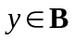.
Since f is a reduction therefore, 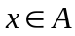 if and only if 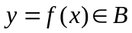. Which implies that N accepts x if and only if. This shows that N is a decider for A.

Question 11: If A ≤m B and B is Turning Recognizable, then A is Turning Recognizable.
Answer:
Let A ≤m B and let f be the reducibility from A to B, Furthermore, since B is turning recognizable, there is a TM M such that L(M)=B

Consider N:
“On input x
- Computer y=f(x)
- Run M on y
- if M accepts, accept.”
Then it is easy to see that L(N) = A.

Question 12: let 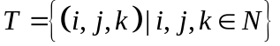.show that T is countable.

Answer:
We need to demonstrate a one-to-one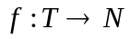. Let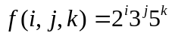. Function f is one-to-one because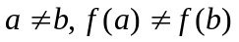. Therefore, T is countable.

Question 13: Let A be a regular expression. Show that A is decidable.

Answer:
1. Proof is actually one line.
2. If we have a decider M that accepts A.
3. We can switch the accept and reject states to make another decider M‟.
4. M‟ accepts. A

Lets recall that a language A is Turing recognizable if there is a TM M such that L(M) = A.

Question 14:

Answer:
For checking the given number “234 and 399” that they are relatively prime or not we use Euclidean algorithm to find Greatest Common Divisor (GCD).
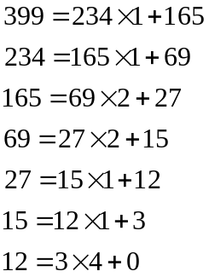

The greatest common divisor of “234 and 399” is 3. There for they are not relatively prime

Question 15: Show that some true statement in TH(N, +, X) are not provable

Answer:
Consider the following algorithm:
1. On input Ф
2. Enumerate all possible proofs 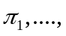
3. Check if 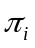 is a proof of Ф. If it is accept.
4. Check if is a proof of ¬Ф. if it is reject.

If all true statements are provable then since each statement is either true or false hence Ф or ≠ Ф is provable. Thus the above algorithm will be a decider for TH(N,+,×) . This is a contradiction as we have already proved that TH(N,+,×) is not decidable.

Question 16: Show that A<TB , B<TC, A< TC

Question 17: MIN_{TM} is not Turing-Recognizable.

Answer:

Two facts about MIN_{TM}.
- 1 MIN_{TM} is infinite.
- 2 MIN_{TM} contains TM’s whose length is arbitrarily large.
If MIN_{TM} is Turing Recognizable then there is a TM E that enumerates MIN_{TM}. We will use E and the recursion theorem to construct another TM C.

On input w
- 2 Obtain own description <C>.
- 3 Run E until a machine D appears with a longer description than that of C.
- 4 Simulate D on input w.

All we have to note that eventually D will appear as MIN_{TM} contains TM with arbitrarily large descriptions. L(C) = L(D).
However, C has a smaller description than D. So D cannot be in MIN_{TM}.

Question 18: A={<R>|R is a regular expression describing a language containing at least one string w that has 111 as substring(i.e.w=x111y for some x,y } show A is decidable.

Answer:
The following TM X decide A.

X = “On input 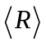 where R is regular Expression:
1. Construct DFA E that accepts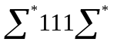.
2. Construct DFA B such that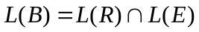.
3. Run TM T on input 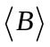 where T decides E_{DFA}.
4. If T accepts, reject. If T rejects, accept.”
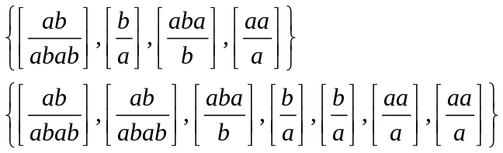

Question 19: Consider following instance of PCP. Is it possible to find a match? If yes then give the dominos arrangements. If NO then prove. 1/0. 101/1. 1/001 (5).

Answer: We can give the number to instances as :
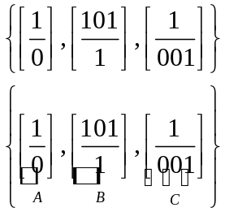

We have choice for start matching that is pair B where 1 is at start from top and bottom so pair B is,
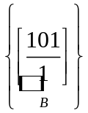

Form pair B we can see that 1 is match in top and bottom string but 01 is left in the upper so we need a pair whose bottom string starts with 0. There are twp pairs A and C.
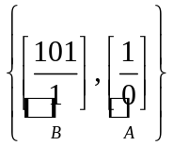 OR 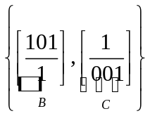 We can not use C because there will be a mismatch so use A.
After using B,A from upper 10 and bottom 10 is matched but 11 is left from upper so we need a pair whose bottom string starts with 1. That is B.
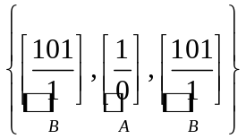 Upper = 101 , Bottom = 101

After using B,A,B from upper 101 and bottom 101 is matched but 1101 is left from upper so we need a pair whose bottom string starts with 1. That is B.
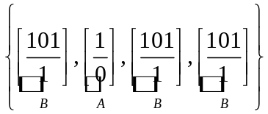 Upper = 1011 , Bottom = 1011

After using B,A,B,B from upper 1011 and bottom 1011 is matched but 101101 is left from upper so we need a pair whose bottom string starts with 1. That is B.
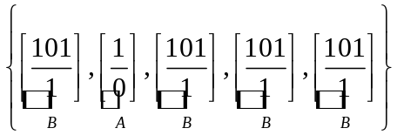 Upper = 10111 , Bottom = 10111
After using B,A,B,B,B from upper 10111 and bottom 10111 is matched but 01101101 is left from upper so we need a pair whose bottom string starts with 0. That is A and C. If we use C there will a mismatch.
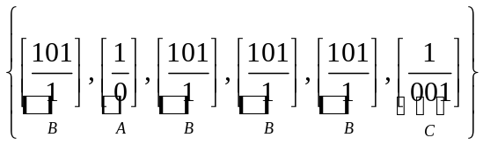 Upper = 1011101 , Bottom = 1011100
So we use A
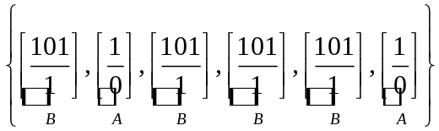 Upper = 101110 , Bottom = 101110
After using B,A,B,B,B,A from upper 101110 and bottom 101110 is matched but 11011011 is left from upper so we need a pair whose bottom string starts with 1. That is B.
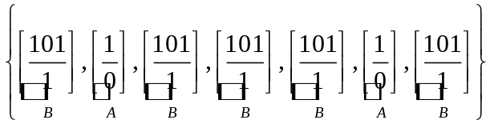
We observe that Upper Values are increasing, we can not use C having bottom 001 because in upper there will not 00 in it. So, it is not possible to find a match for this instance.

Question 20: In the silly Post Correspondence Problem, SPCP, in each pair the top string has the same length as the bottom string. Show that the SPCP is decidable. 10
Answer: The SPCP problem is decidable. It follows from the following claim.
Claim: A given SPCP instance has a match if and only if there is a domino 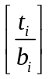 such that 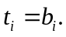
Proof of the claim:
” ”: If a SPCP instance has a match it has to start with some domino. Because the length of the top and the bottom string is the same in all dominos, the first domino in the match must surely have the same top and bottom string.
” 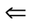”: If there is a domino with the same top and bottom string then this single domino forms a trivial match of SPCP.

Finally, checking whether there is a domino with the same top and bottom string is easily decidable by examining the SPCP instance.

Question 22: 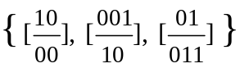

Solution:
We can give the number to instances as:
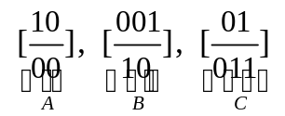
We have choice for start matching that is pair C where 0 is at start from top and bottom so pair C is,
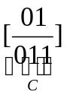
Form pair c we can see that 01 is match in top and bottom string but 1 is left in the bottom so we need a pair whose upper string starts with 1 that is pair A
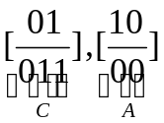
Now 0110 string is match from top and bottom,0 is left from bottom so we need a pair, who’s upper string starts with 0, there are two choice either select pair B or C. Let’s first try with pair B,
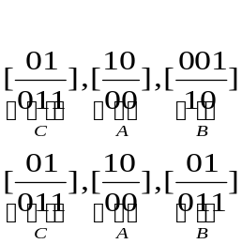
It does not match, so let’s try pair C,

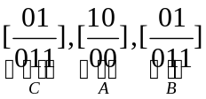
Again we have a mismatch. There is no other pair left. So, it is not possible to find a match for this instance.
Question 23: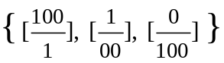
Solution:
We can give the number to instances as
Numbering the instances as follows:
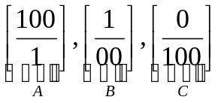
The dominos arrangement which will gives the matching of top and bottom string is:
A, B, A, A, B, C, C
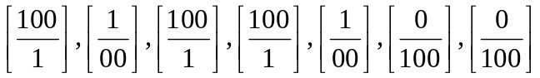
Now if we note the top string that is 1001100100100
If we note bottom string that is 1001100100100
Now the matching is found so this list is called match.

Question 24: 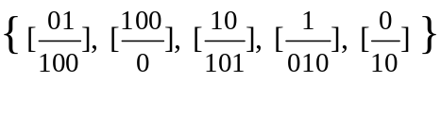
Solution:
We can give the number to instances as :
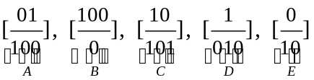
We have choice for start matching that is pair C where 1 is at start from top and bottom so pair C is,
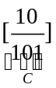
Form pair c we can see that 10 is match in top and bottom string but 1 is left in the bottom so we need a pair whose upper string starts with 1 that is pair D
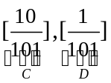
Now 010 is left from bottom and we need a string that is start from 0 at the top which is A
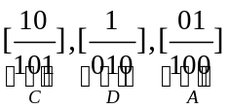 Now the matching string is 10101, 0100 is left in the bottom , we need string with 0 from top that is E
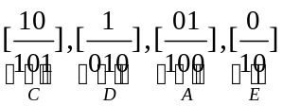 now matching string is 101010, 10010 is left in the bottom, so the best choice pair B
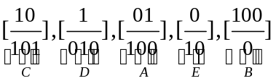 matching is 101010100, 100 is left from bottom
So choose pair B again
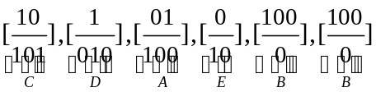 now 0 is left from bottom so choose pair E
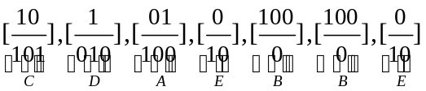 now 10 s left from bottom, choose pair B
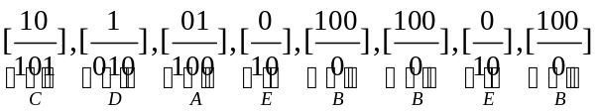
So the matching string is 1010101001000100
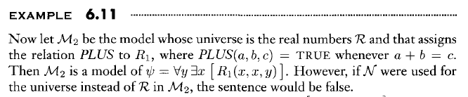
Theorem: ALLCFG is undecidable.

If ALL_{CFG} is decidable then there is a decider R such that L(R) = ALL_{CFG}
Suppose R decides ALL_{CFG} then consider S
1. On input <M, w>
2. Construct and LBA D as described earlier.
3. Convert D into an equivalent CFG G.
4. Run R on G. If R accepts reject. If R rejects accepts.

Note that S is a decider for A TM. A contradiction.

Theorem: HALT_{TM} is undecidable.

Suppose that HALT_{TM} is decidable and R decides HALT_{TM}. If we have R then we have no problem on TM that loop endlessly. We can always check if a TM will loop endlessly on a given input using R. We can use R to make a decider for ATM. We know that ATM is undecidable. We have a contradiction and that is why R cannot exist.
Given R we can construct S which decides ATM that operates as follows:

1. On input <M, w>
2. Run TM R on input <M, w>.
3. If R rejects, reject.
4. If R accepts, simulate M on w until it halts.
5. If M has accepted w, accept; if M has rejected w, reject.

Note that S will reject <M, w> even if M loops on w.

